Assignment CO2
CSA05 Database Management Systems – CO2: SwiftSpan Parcels – Courier Handover Completion (MySQL)

Queries

A. Create database and tables (Design 1 flat, Design 2 partial, Design 3 BCNF)
- CREATE DATABASE IF NOT EXISTS swiftspan_co2;
- USE swiftspan_co2;
- CREATE TABLE d1_flat (
sender_id INT NOT NULL,
service_id INT NOT NULL,
dispatch_wave TINYINT NOT NULL,
sender_name VARCHAR(40) NOT NULL,
route_group VARCHAR(10) NOT NULL,
service_code VARCHAR(20) NOT NULL,
service_name VARCHAR(60) NOT NULL,
volume_weight DECIMAL(4,2) NOT NULL,
coordinator_id INT NOT NULL,
coordinator_name VARCHAR(40) NOT NULL,
hub VARCHAR(10) NOT NULL,
completion TINYINT NOT NULL,
service_band CHAR(1) NOT NULL,
route_factor DECIMAL(3,2) NOT NULL,
PRIMARY KEY (sender_id, service_id, dispatch_wave),
UNIQUE KEY uq_d1_alt_key (sender_id, service_code, dispatch_wave),
KEY ix_d1_wave (dispatch_wave),
KEY ix_d1_completion (completion),
KEY ix_d1_service (service_id),
KEY ix_d1_coord (coordinator_id),
KEY ix_d1_band (service_band),
CONSTRAINT chk_d1_completion CHECK (completion BETWEEN 0 AND 100),
CONSTRAINT chk_d1_band CHECK (service_band IN ('A','B','C','D'))
) ENGINE=InnoDB;
- CREATE TABLE d2_sender (
sender_id INT NOT NULL PRIMARY KEY,
sender_name VARCHAR(40) NOT NULL,
route_group VARCHAR(10) NOT NULL
) ENGINE=InnoDB;
- CREATE TABLE d2_service (
service_id INT NOT NULL PRIMARY KEY,
service_code VARCHAR(20) NOT NULL,
service_name VARCHAR(60) NOT NULL,
volume_weight DECIMAL(4,2) NOT NULL,
CONSTRAINT uq_d2_service_code UNIQUE (service_code)
) ENGINE=InnoDB;
- CREATE TABLE d2_observation (
sender_id INT NOT NULL,
service_id INT NOT NULL,
dispatch_wave TINYINT NOT NULL,
coordinator_id INT NOT NULL,
coordinator_name VARCHAR(40) NOT NULL,
hub VARCHAR(10) NOT NULL,
completion TINYINT NOT NULL,
service_band CHAR(1) NOT NULL,
route_factor DECIMAL(3,2) NOT NULL,
PRIMARY KEY (sender_id, service_id, dispatch_wave),
KEY ix_d2_wave (dispatch_wave),
KEY ix_d2_completion (completion),
KEY ix_d2_service (service_id),
KEY ix_d2_coord (coordinator_id),
KEY ix_d2_band (service_band),
CONSTRAINT fk_d2_obs_sender FOREIGN KEY (sender_id)
REFERENCES d2_sender (sender_id) ON DELETE RESTRICT ON UPDATE RESTRICT,
CONSTRAINT fk_d2_obs_service FOREIGN KEY (service_id)
REFERENCES d2_service (service_id) ON DELETE RESTRICT ON UPDATE RESTRICT,
CONSTRAINT chk_d2_obs_completion CHECK (completion BETWEEN 0 AND 100),
CONSTRAINT chk_d2_obs_band CHECK (service_band IN ('A','B','C','D'))
) ENGINE=InnoDB;
- CREATE TABLE d3_sender (
sender_id INT NOT NULL PRIMARY KEY,
sender_name VARCHAR(40) NOT NULL,
route_group VARCHAR(10) NOT NULL
) ENGINE=InnoDB;
- CREATE TABLE d3_service (
service_id INT NOT NULL PRIMARY KEY,
service_code VARCHAR(20) NOT NULL,
service_name VARCHAR(60) NOT NULL,
volume_weight DECIMAL(4,2) NOT NULL,
CONSTRAINT uq_d3_service_code UNIQUE (service_code)
) ENGINE=InnoDB;
- CREATE TABLE d3_coordinator (
coordinator_id INT NOT NULL PRIMARY KEY,
coordinator_name VARCHAR(40) NOT NULL,
hub VARCHAR(10) NOT NULL
) ENGINE=InnoDB;
- CREATE TABLE d3_band_factor (
service_band CHAR(1) NOT NULL PRIMARY KEY,
route_factor DECIMAL(3,2) NOT NULL,
CONSTRAINT chk_d3_band CHECK (service_band IN ('A','B','C','D'))
) ENGINE=InnoDB;
- CREATE TABLE d3_completion_band (
completion TINYINT NOT NULL PRIMARY KEY,
service_band CHAR(1) NOT NULL,
CONSTRAINT fk_d3_cb_band FOREIGN KEY (service_band)
REFERENCES d3_band_factor (service_band) ON DELETE RESTRICT ON UPDATE RESTRICT,
CONSTRAINT chk_d3_cb_completion CHECK (completion BETWEEN 0 AND 100)
) ENGINE=InnoDB;
- CREATE TABLE d3_assignment (
sender_id INT NOT NULL,
service_id INT NOT NULL,
coordinator_id INT NOT NULL,
PRIMARY KEY (sender_id, service_id),
KEY ix_d3_assign_coord (coordinator_id),
KEY ix_d3_assign_service (service_id),
CONSTRAINT fk_d3_assign_sender FOREIGN KEY (sender_id)
REFERENCES d3_sender (sender_id) ON DELETE RESTRICT ON UPDATE RESTRICT,
CONSTRAINT fk_d3_assign_service FOREIGN KEY (service_id)
REFERENCES d3_service (service_id) ON DELETE RESTRICT ON UPDATE RESTRICT,
CONSTRAINT fk_d3_assign_coord FOREIGN KEY (coordinator_id)
REFERENCES d3_coordinator (coordinator_id) ON DELETE RESTRICT ON UPDATE RESTRICT
) ENGINE=InnoDB;
- CREATE TABLE d3_observation (
sender_id INT NOT NULL,
service_id INT NOT NULL,
dispatch_wave TINYINT NOT NULL,
completion TINYINT NOT NULL,
PRIMARY KEY (sender_id, service_id, dispatch_wave),
KEY ix_d3_wave (dispatch_wave),
KEY ix_d3_completion (completion),
CONSTRAINT fk_d3_obs_assignment FOREIGN KEY (sender_id, service_id)
REFERENCES d3_assignment (sender_id, service_id) ON DELETE RESTRICT ON UPDATE RESTRICT,
CONSTRAINT fk_d3_obs_completion FOREIGN KEY (completion)
REFERENCES d3_completion_band (completion) ON DELETE RESTRICT ON UPDATE RESTRICT,
CONSTRAINT chk_d3_obs_completion CHECK (completion BETWEEN 0 AND 100)
) ENGINE=InnoDB;
- CREATE TABLE digits (d INT NOT NULL PRIMARY KEY) ENGINE=InnoDB;
- CREATE TABLE nums (n INT NOT NULL PRIMARY KEY) ENGINE=InnoDB;
- CREATE TABLE stage_obs (
sender_id INT NOT NULL,
service_id INT NOT NULL,
dispatch_wave TINYINT NOT NULL,
completion TINYINT NOT NULL,
PRIMARY KEY (sender_id, service_id, dispatch_wave)
) ENGINE=InnoDB;
- CREATE TABLE experiment_result (
result_id INT AUTO_INCREMENT PRIMARY KEY,
population INT NOT NULL,
design VARCHAR(12) NOT NULL,
metric VARCHAR(24) NOT NULL,
detail VARCHAR(48) NOT NULL,
value_num DOUBLE NOT NULL,
unit VARCHAR(10) NOT NULL
) ENGINE=InnoDB;
- SHOW TABLES;

B. Load identical seeded data into all three designs
- INSERT INTO digits VALUES (0),(1),(2),(3),(4),(5),(6),(7),(8),(9);
- INSERT INTO nums
SELECT a.d + 10*b.d + 100*c.d + 1000*e.d + 10000*f.d
FROM digits a, digits b, digits c, digits e, digits f;
- DELIMITER //
CREATE PROCEDURE load_population(IN p_senders INT)
BEGIN
DECLARE p_coord INT;
SET p_coord = GREATEST(p_senders DIV 10, 1);
SET FOREIGN_KEY_CHECKS = 0;
TRUNCATE TABLE d1_flat;
TRUNCATE TABLE d2_observation;
TRUNCATE TABLE d2_sender;
TRUNCATE TABLE d2_service;
TRUNCATE TABLE d3_observation;
TRUNCATE TABLE d3_assignment;
TRUNCATE TABLE d3_coordinator;
TRUNCATE TABLE d3_sender;
TRUNCATE TABLE d3_service;
TRUNCATE TABLE d3_completion_band;
TRUNCATE TABLE d3_band_factor;
TRUNCATE TABLE stage_obs;
SET FOREIGN_KEY_CHECKS = 1;
INSERT INTO d3_band_factor VALUES ('D',0.70),('C',0.85),('B',1.00),('A',1.10);
INSERT INTO d3_completion_band (completion, service_band)
SELECT n, CASE WHEN n <= 38 THEN 'D' WHEN n <= 59 THEN 'C'
WHEN n <= 79 THEN 'B' ELSE 'A' END
FROM nums WHERE n <= 100;
INSERT INTO d3_service VALUES
(1,'SVC-STD','Standard Parcel',1.00),(2,'SVC-EXP','Express Delivery',1.50),
(3,'SVC-COLD','Cold Chain',2.00),(4,'SVC-FRG','Fragile Handling',1.25),
(5,'SVC-BLK','Bulk Freight',2.50);
INSERT INTO d3_sender
SELECT n + 1, CONCAT('Sender-', LPAD(n + 1, 5, '0')), CONCAT('RG-', MOD(n, 4) + 1)
FROM nums WHERE n < p_senders;
INSERT INTO d3_coordinator
SELECT n + 1, CONCAT('Coordinator-', LPAD(n + 1, 4, '0')), CONCAT('Hub-', MOD(n, 5) + 1)
FROM nums WHERE n < p_coord;
INSERT INTO d3_assignment
SELECT s.sender_id, v.service_id, MOD(s.sender_id * 7 + v.service_id * 3, p_coord) + 1
FROM d3_sender s CROSS JOIN d3_service v;
INSERT INTO stage_obs
SELECT s.sender_id, v.service_id, w.n,
IF(MOD(CRC32(CONCAT('L-', s.sender_id, '-', v.service_id, '-', w.n)), 10) = 0,
MOD(CRC32(CONCAT('X-', s.sender_id, '-', v.service_id, '-', w.n)), 39),
40 + MOD(CRC32(CONCAT('C-', s.sender_id, '-', v.service_id, '-', w.n)), 61))
FROM d3_sender s CROSS JOIN d3_service v JOIN nums w ON w.n BETWEEN 1 AND 4;
INSERT INTO d3_observation SELECT * FROM stage_obs;
INSERT INTO d2_sender SELECT * FROM d3_sender;
INSERT INTO d2_service SELECT * FROM d3_service;
INSERT INTO d2_observation
SELECT o.sender_id, o.service_id, o.dispatch_wave, a.coordinator_id, c.coordinator_name, c.hub,
o.completion, cb.service_band, bf.route_factor
FROM stage_obs o
JOIN d3_assignment a ON a.sender_id = o.sender_id AND a.service_id = o.service_id
JOIN d3_coordinator c ON c.coordinator_id = a.coordinator_id
JOIN d3_completion_band cb ON cb.completion = o.completion
JOIN d3_band_factor bf ON bf.service_band = cb.service_band;
INSERT INTO d1_flat
SELECT o.sender_id, o.service_id, o.dispatch_wave, s.sender_name, s.route_group,
v.service_code, v.service_name, v.volume_weight, a.coordinator_id, c.coordinator_name, c.hub,
o.completion, cb.service_band, bf.route_factor
FROM stage_obs o
JOIN d3_sender s ON s.sender_id = o.sender_id
JOIN d3_service v ON v.service_id = o.service_id
JOIN d3_assignment a ON a.sender_id = o.sender_id AND a.service_id = o.service_id
JOIN d3_coordinator c ON c.coordinator_id = a.coordinator_id
JOIN d3_completion_band cb ON cb.completion = o.completion
JOIN d3_band_factor bf ON bf.service_band = cb.service_band;
END//
DELIMITER ;
- CALL load_population(500);

C. Row counts
- SELECT 'd1_flat' AS table_name, COUNT(*) AS row_count FROM d1_flat
UNION ALL SELECT 'd2_sender', COUNT(*) FROM d2_sender
UNION ALL SELECT 'd2_service', COUNT(*) FROM d2_service
UNION ALL SELECT 'd2_observation', COUNT(*) FROM d2_observation
UNION ALL SELECT 'd3_sender', COUNT(*) FROM d3_sender
UNION ALL SELECT 'd3_service', COUNT(*) FROM d3_service
UNION ALL SELECT 'd3_coordinator', COUNT(*) FROM d3_coordinator
UNION ALL SELECT 'd3_band_factor', COUNT(*) FROM d3_band_factor
UNION ALL SELECT 'd3_completion_band', COUNT(*) FROM d3_completion_band
UNION ALL SELECT 'd3_assignment', COUNT(*) FROM d3_assignment
UNION ALL SELECT 'd3_observation', COUNT(*) FROM d3_observation;

D. Use-case queries 1–5 (Design 3, BCNF)
- -- Query 1: Actor 1, DispatchWave 4, weighted adjusted index = Completion x VolumeWeight x RouteFactor
SELECT o.sender_id, v.service_code, o.dispatch_wave AS wave, o.completion,
cb.service_band AS band, bf.route_factor AS factor, v.volume_weight AS weight,
ROUND(o.completion * v.volume_weight * bf.route_factor, 2) AS adj_index
FROM d3_observation o
JOIN d3_service v ON v.service_id = o.service_id
JOIN d3_completion_band cb ON cb.completion = o.completion
JOIN d3_band_factor bf ON bf.service_band = cb.service_band
WHERE o.sender_id = 1 AND o.dispatch_wave = 4
ORDER BY o.service_id;
- -- Query 2: Senders meeting threshold 39 for every required service (relational division)
SELECT s.sender_id, s.sender_name, s.route_group
FROM d3_sender s
JOIN d3_observation o ON o.sender_id = s.sender_id
GROUP BY s.sender_id, s.sender_name, s.route_group
HAVING MIN(o.completion) >= 39
AND COUNT(DISTINCT o.service_id) = (SELECT COUNT(*) FROM d3_service)
ORDER BY s.sender_id
LIMIT 10;
- -- Query 3: Observed service records with no value below 39 in period 4 (no vacuous inclusion)
SELECT o.sender_id, v.service_code
FROM d3_observation o
JOIN d3_service v ON v.service_id = o.service_id
WHERE o.dispatch_wave = 4
GROUP BY o.sender_id, o.service_id, v.service_code
HAVING MIN(o.completion) >= 39
ORDER BY o.sender_id, o.service_id
LIMIT 10;
- -- Query 4: Coordinator means below the observation-weighted hub mean (aggregate extension)
WITH coord_stats AS (
SELECT c.coordinator_id, c.coordinator_name, c.hub, AVG(o.completion) AS coord_mean
FROM d3_observation o
JOIN d3_assignment a ON a.sender_id = o.sender_id AND a.service_id = o.service_id
JOIN d3_coordinator c ON c.coordinator_id = a.coordinator_id
GROUP BY c.coordinator_id, c.coordinator_name, c.hub),
hub_stats AS (
SELECT c.hub, AVG(o.completion) AS hub_mean
FROM d3_observation o
JOIN d3_assignment a ON a.sender_id = o.sender_id AND a.service_id = o.service_id
JOIN d3_coordinator c ON c.coordinator_id = a.coordinator_id
GROUP BY c.hub)
SELECT cs.coordinator_id, cs.coordinator_name, cs.hub,
ROUND(cs.coord_mean, 2) AS coord_mean, ROUND(hs.hub_mean, 2) AS hub_mean
FROM coord_stats cs
JOIN hub_stats hs ON hs.hub = cs.hub
WHERE cs.coord_mean < hs.hub_mean
ORDER BY cs.hub, cs.coordinator_id
LIMIT 10;
- -- Query 5: Senders with sub-threshold observations in at least 3 distinct dispatch waves
SELECT s.sender_id, s.sender_name, COUNT(DISTINCT o.dispatch_wave) AS waves_below
FROM d3_observation o
JOIN d3_sender s ON s.sender_id = o.sender_id
WHERE o.completion < 39
GROUP BY s.sender_id, s.sender_name
HAVING COUNT(DISTINCT o.dispatch_wave) >= 3
ORDER BY s.sender_id
LIMIT 10;

E. Views, lossless-join check and GRANT/REVOKE examples
- -- Operational view: reconstructs the full 14-attribute handover line
CREATE VIEW v_operational_obs AS
SELECT o.sender_id, o.service_id, o.dispatch_wave, s.sender_name, s.route_group, v.service_code, v.service_name,
v.volume_weight, a.coordinator_id, c.coordinator_name, c.hub, o.completion, cb.service_band, bf.route_factor
FROM d3_observation o
JOIN d3_sender s ON s.sender_id = o.sender_id
JOIN d3_service v ON v.service_id = o.service_id
JOIN d3_assignment a ON a.sender_id = o.sender_id AND a.service_id = o.service_id
JOIN d3_coordinator c ON c.coordinator_id = a.coordinator_id
JOIN d3_completion_band cb ON cb.completion = o.completion
JOIN d3_band_factor bf ON bf.service_band = cb.service_band;
- -- Actor view: sender-level summary only (no coordinator or policy columns)
CREATE VIEW v_actor_summary AS
SELECT s.sender_id, s.sender_name, s.route_group, COUNT(*) AS observations,
ROUND(AVG(o.completion), 2) AS avg_completion, MIN(o.completion) AS min_completion
FROM d3_sender s JOIN d3_observation o ON o.sender_id = s.sender_id
GROUP BY s.sender_id, s.sender_name, s.route_group;
- -- Operational view: coordinator means
CREATE VIEW v_coordinator_mean AS
SELECT c.coordinator_id, c.coordinator_name, c.hub, COUNT(*) AS observations, ROUND(AVG(o.completion), 2) AS coord_mean
FROM d3_observation o
JOIN d3_assignment a ON a.sender_id = o.sender_id AND a.service_id = o.service_id
JOIN d3_coordinator c ON c.coordinator_id = a.coordinator_id
GROUP BY c.coordinator_id, c.coordinator_name, c.hub;
- SELECT * FROM v_actor_summary WHERE sender_id <= 5;
- SELECT sender_id, service_code, dispatch_wave AS wave, completion, service_band AS band, route_factor AS factor,
coordinator_name, hub
FROM v_operational_obs
WHERE sender_id = 1 AND dispatch_wave = 4
ORDER BY service_id;
- SELECT * FROM v_coordinator_mean ORDER BY coordinator_id LIMIT 5;
- -- Lossless-join check: the BCNF join must reproduce exactly the flat relation
SELECT (SELECT COUNT(*) FROM (SELECT * FROM d1_flat EXCEPT SELECT * FROM v_operational_obs) a) AS flat_minus_view,
(SELECT COUNT(*) FROM (SELECT * FROM v_operational_obs EXCEPT SELECT * FROM d1_flat) b) AS view_minus_flat;
- -- GRANT / REVOKE examples (NOT executed - shown as privilege design only; views do not by themselves enforce row identity)
CREATE ROLE IF NOT EXISTS actor_role, ops_role;
GRANT SELECT ON swiftspan_co2.v_actor_summary TO actor_role;
GRANT SELECT ON swiftspan_co2.v_operational_obs TO ops_role;
GRANT SELECT, UPDATE (coordinator_name) ON swiftspan_co2.d3_coordinator TO ops_role;
REVOKE UPDATE (coordinator_name) ON swiftspan_co2.d3_coordinator FROM ops_role;
REVOKE SELECT ON swiftspan_co2.v_operational_obs FROM ops_role;

F. Anomaly demonstrations and rolled-back update trials
- -- F1: update anomaly in the flat design (inconsistent copies of ServiceName)
START TRANSACTION;
- UPDATE d1_flat SET service_name = 'Standard Parcel (renamed)'
WHERE sender_id = 1 AND service_id = 1 AND dispatch_wave = 1;
- SELECT service_id, service_name, COUNT(*) AS copies
FROM d1_flat WHERE service_id = 1
GROUP BY service_id, service_name;
- ROLLBACK;
- -- F2: insertion (orphan catalog fact) and deletion anomaly
START TRANSACTION;
- INSERT INTO d3_service VALUES (6,'SVC-NEW','Same-Day Locker',0.75);
- SELECT * FROM d3_service WHERE service_id = 6;
- INSERT INTO d1_flat VALUES
(1,6,1,'Sender-00001','RG-1','SVC-NEW','Same-Day Locker',0.75,1,'Coordinator-0001','Hub-1',70,'B',1.00);
- DELETE FROM d1_flat WHERE service_id = 6;
- SELECT COUNT(*) AS d1_rows_for_service_6 FROM d1_flat WHERE service_id = 6;
- SELECT COUNT(*) AS d3_catalog_rows_for_service_6 FROM d3_service WHERE service_id = 6;
- ROLLBACK;
- -- catalog: service_id=1 (rolled-back trial)
START TRANSACTION;
- UPDATE d1_flat SET service_name = 'Standard Parcel Plus' WHERE service_id = 1;
- UPDATE d2_service SET service_name = 'Standard Parcel Plus' WHERE service_id = 1;
- UPDATE d3_service SET service_name = 'Standard Parcel Plus' WHERE service_id = 1;
- ROLLBACK;
- -- operator: coordinator_id=1 (rolled-back trial)
START TRANSACTION;
- UPDATE d1_flat SET coordinator_name = 'Coordinator-0001 (Renamed)' WHERE coordinator_id = 1;
- UPDATE d2_observation SET coordinator_name = 'Coordinator-0001 (Renamed)' WHERE coordinator_id = 1;
- UPDATE d3_coordinator SET coordinator_name = 'Coordinator-0001 (Renamed)' WHERE coordinator_id = 1;
- ROLLBACK;
- -- policy: band C factor (rolled-back trial)
START TRANSACTION;
- UPDATE d1_flat SET route_factor = 0.90 WHERE service_band = 'C';
- UPDATE d2_observation SET route_factor = 0.90 WHERE service_band = 'C';
- UPDATE d3_band_factor SET route_factor = 0.90 WHERE service_band = 'C';
- ROLLBACK;
- -- Repeat the three trials after reloading 100,000 and 600,000 observation rows
CALL load_population(5000);
- CALL load_population(30000);
- -- F4: repeated facts still stored (copies beyond the first) at 10,000 observations
SELECT 'd1_flat' AS design,
COUNT(*) - COUNT(DISTINCT service_id) AS service_name_copies,
COUNT(*) - COUNT(DISTINCT coordinator_id) AS coordinator_name_copies,
COUNT(*) - COUNT(DISTINCT service_band) AS route_factor_copies
FROM d1_flat
UNION ALL
SELECT 'd2_partial',
(SELECT COUNT(*) - COUNT(DISTINCT service_id) FROM d2_service),
COUNT(*) - COUNT(DISTINCT coordinator_id),
COUNT(*) - COUNT(DISTINCT service_band)
FROM d2_observation
UNION ALL
SELECT 'd3_bcnf',
(SELECT COUNT(*) - COUNT(DISTINCT service_id) FROM d3_service),
(SELECT COUNT(*) - COUNT(DISTINCT coordinator_id) FROM d3_coordinator),
(SELECT COUNT(*) - COUNT(DISTINCT service_band) FROM d3_band_factor);
- -- F5: the partial design accepts a band that contradicts the Completion -> ServiceBand policy
START TRANSACTION;
- UPDATE d2_observation SET service_band = 'A'
WHERE sender_id = 1 AND service_id = 1 AND dispatch_wave = 1;
- SELECT sender_id, service_id, dispatch_wave AS wave, completion, service_band AS band
FROM d2_observation
WHERE sender_id = 1 AND service_id = 1 AND dispatch_wave = 1;
- ROLLBACK;

G. Recorded experimental results (10,000 / 100,000 / 600,000 observations)
- -- Results recorded from the three test runs (10,000 / 100,000 / 600,000 observations)
INSERT INTO experiment_result (population, design, metric, detail, value_num, unit) VALUES
(10000,'d1_flat','allocated_bytes','data+indexes',2031616,'bytes'),(10000,'d1_flat','data_bytes','clustered data',1064960,'bytes'),(10000,'d1_flat','index_bytes','secondary/unique indexes',966656,'bytes'),
(10000,'d1_flat','allocated_pages','16 KiB pages',124,'pages'),(10000,'d2_partial','allocated_bytes','data+indexes',1327104,'bytes'),(10000,'d2_partial','data_bytes','clustered data',573440,'bytes'),
(10000,'d2_partial','index_bytes','secondary/unique indexes',753664,'bytes'),(10000,'d2_partial','allocated_pages','16 KiB pages',81,'pages'),(10000,'d3_bcnf','allocated_bytes','data+indexes',704512,'bytes'),
(10000,'d3_bcnf','data_bytes','clustered data',294912,'bytes'),(10000,'d3_bcnf','index_bytes','secondary/unique indexes',409600,'bytes'),(10000,'d3_bcnf','allocated_pages','16 KiB pages',43,'pages'),
(10000,'d1_flat','rows_returned','Q1',5,'rows'),(10000,'d1_flat','result_checksum','Q1',238408767,'hash'),(10000,'d1_flat','median_ms','Q1',0.01,'ms'),
(0,'d1_flat','logical_joins','Q1',0,'joins'),(10000,'d2_partial','rows_returned','Q1',5,'rows'),(10000,'d2_partial','result_checksum','Q1',238408767,'hash'),
(10000,'d2_partial','median_ms','Q1',0.01,'ms'),(0,'d2_partial','logical_joins','Q1',1,'joins'),(10000,'d3_bcnf','rows_returned','Q1',5,'rows'),
(10000,'d3_bcnf','result_checksum','Q1',238408767,'hash'),(10000,'d3_bcnf','median_ms','Q1',0.01,'ms'),(0,'d3_bcnf','logical_joins','Q1',3,'joins'),
(10000,'d1_flat','rows_returned','Q2',57,'rows'),(10000,'d1_flat','result_checksum','Q2',153510960,'hash'),(10000,'d1_flat','median_ms','Q2',4.67,'ms'),
(0,'d1_flat','logical_joins','Q2',0,'joins'),(10000,'d2_partial','rows_returned','Q2',57,'rows'),(10000,'d2_partial','result_checksum','Q2',153510960,'hash'),
(10000,'d2_partial','median_ms','Q2',2.23,'ms'),(0,'d2_partial','logical_joins','Q2',1,'joins'),(10000,'d3_bcnf','rows_returned','Q2',57,'rows'),
(10000,'d3_bcnf','result_checksum','Q2',153510960,'hash'),(10000,'d3_bcnf','median_ms','Q2',2.12,'ms'),(0,'d3_bcnf','logical_joins','Q2',1,'joins'),
(10000,'d1_flat','rows_returned','Q3',2258,'rows'),(10000,'d1_flat','result_checksum','Q3',138047711,'hash'),(10000,'d1_flat','median_ms','Q3',3.06,'ms'),
(0,'d1_flat','logical_joins','Q3',0,'joins'),(10000,'d2_partial','rows_returned','Q3',2258,'rows'),(10000,'d2_partial','result_checksum','Q3',138047711,'hash'),
(10000,'d2_partial','median_ms','Q3',3.12,'ms'),(0,'d2_partial','logical_joins','Q3',1,'joins'),(10000,'d3_bcnf','rows_returned','Q3',2258,'rows'),
(10000,'d3_bcnf','result_checksum','Q3',138047711,'hash'),(10000,'d3_bcnf','median_ms','Q3',3,'ms'),(0,'d3_bcnf','logical_joins','Q3',1,'joins'),
(10000,'d1_flat','rows_returned','Q4',23,'rows'),(10000,'d1_flat','result_checksum','Q4',7132941,'hash'),(10000,'d1_flat','median_ms','Q4',8.99,'ms'),
(0,'d1_flat','logical_joins','Q4',1,'joins'),(10000,'d2_partial','rows_returned','Q4',23,'rows'),(10000,'d2_partial','result_checksum','Q4',7132941,'hash'),
(10000,'d2_partial','median_ms','Q4',8.58,'ms'),(0,'d2_partial','logical_joins','Q4',1,'joins'),(10000,'d3_bcnf','rows_returned','Q4',23,'rows'),
(10000,'d3_bcnf','result_checksum','Q4',7132941,'hash'),(10000,'d3_bcnf','median_ms','Q4',17.54,'ms'),(0,'d3_bcnf','logical_joins','Q4',5,'joins'),
(10000,'d1_flat','rows_returned','Q5',100,'rows'),(10000,'d1_flat','result_checksum','Q5',125686658,'hash'),(10000,'d1_flat','median_ms','Q5',0.89,'ms'),
(0,'d1_flat','logical_joins','Q5',0,'joins'),(10000,'d2_partial','rows_returned','Q5',100,'rows'),(10000,'d2_partial','result_checksum','Q5',125686658,'hash'),
(10000,'d2_partial','median_ms','Q5',0.7,'ms'),(0,'d2_partial','logical_joins','Q5',1,'joins'),(10000,'d3_bcnf','rows_returned','Q5',100,'rows'),
(10000,'d3_bcnf','result_checksum','Q5',125686658,'hash'),(10000,'d3_bcnf','median_ms','Q5',0.73,'ms'),(0,'d3_bcnf','logical_joins','Q5',1,'joins'),
(10000,'d1_flat','rows_touched','catalog: service_id=1',2000,'rows'),(10000,'d2_partial','rows_touched','catalog: service_id=1',1,'rows'),(10000,'d3_bcnf','rows_touched','catalog: service_id=1',1,'rows'),
(10000,'d1_flat','rows_touched','operator: coordinator_id=1',200,'rows'),(10000,'d2_partial','rows_touched','operator: coordinator_id=1',200,'rows'),(10000,'d3_bcnf','rows_touched','operator: coordinator_id=1',1,'rows'),
(10000,'d1_flat','rows_touched','policy: band C factor',2982,'rows'),(10000,'d2_partial','rows_touched','policy: band C factor',2982,'rows'),(10000,'d3_bcnf','rows_touched','policy: band C factor',1,'rows'),
(10000,'d3_card','refresh_ms','full rebuild in one transaction',4.8,'ms'),(10000,'d3_card','card_rows','sender x service',2500,'rows'),(10000,'d3_card','allocated_bytes','read card table',311296,'bytes'),
(10000,'d3_bcnf','lookup_median_ms','sender tracking lookup (5 rows)',0.017,'ms'),(10000,'d3_card','lookup_median_ms','sender tracking lookup (5 rows)',0.01,'ms'),(0,'d3_bcnf','logical_joins','lookup',6,'joins'),
(0,'d3_card','logical_joins','lookup',0,'joins'),(100000,'d1_flat','allocated_bytes','data+indexes',19578880,'bytes'),(100000,'d1_flat','data_bytes','clustered data',10747904,'bytes'),
(100000,'d1_flat','index_bytes','secondary/unique indexes',8830976,'bytes'),(100000,'d1_flat','allocated_pages','16 KiB pages',1195,'pages'),(100000,'d2_partial','allocated_bytes','data+indexes',12271616,'bytes'),
(100000,'d2_partial','data_bytes','clustered data',5570560,'bytes'),(100000,'d2_partial','index_bytes','secondary/unique indexes',6701056,'bytes'),(100000,'d2_partial','allocated_pages','16 KiB pages',749,'pages'),
(100000,'d3_bcnf','allocated_bytes','data+indexes',5242880,'bytes'),(100000,'d3_bcnf','data_bytes','clustered data',2015232,'bytes'),(100000,'d3_bcnf','index_bytes','secondary/unique indexes',3227648,'bytes'),
(100000,'d3_bcnf','allocated_pages','16 KiB pages',320,'pages'),(100000,'d1_flat','rows_returned','Q1',5,'rows'),(100000,'d1_flat','result_checksum','Q1',238408767,'hash'),
(100000,'d1_flat','median_ms','Q1',0.01,'ms'),(100000,'d2_partial','rows_returned','Q1',5,'rows'),(100000,'d2_partial','result_checksum','Q1',238408767,'hash'),
(100000,'d2_partial','median_ms','Q1',0.01,'ms'),(100000,'d3_bcnf','rows_returned','Q1',5,'rows'),(100000,'d3_bcnf','result_checksum','Q1',238408767,'hash'),
(100000,'d3_bcnf','median_ms','Q1',0.01,'ms'),(100000,'d1_flat','rows_returned','Q2',564,'rows'),(100000,'d1_flat','result_checksum','Q2',77112202,'hash'),
(100000,'d1_flat','median_ms','Q2',46.12,'ms'),(100000,'d2_partial','rows_returned','Q2',564,'rows'),(100000,'d2_partial','result_checksum','Q2',77112202,'hash'),
(100000,'d2_partial','median_ms','Q2',21.77,'ms'),(100000,'d3_bcnf','rows_returned','Q2',564,'rows'),(100000,'d3_bcnf','result_checksum','Q2',77112202,'hash'),
(100000,'d3_bcnf','median_ms','Q2',20.57,'ms'),(100000,'d1_flat','rows_returned','Q3',22510,'rows'),(100000,'d1_flat','result_checksum','Q3',123342480,'hash'),
(100000,'d1_flat','median_ms','Q3',34.28,'ms'),(100000,'d2_partial','rows_returned','Q3',22510,'rows'),(100000,'d2_partial','result_checksum','Q3',123342480,'hash'),
(100000,'d2_partial','median_ms','Q3',32.69,'ms'),(100000,'d3_bcnf','rows_returned','Q3',22510,'rows'),(100000,'d3_bcnf','result_checksum','Q3',123342480,'hash'),
(100000,'d3_bcnf','median_ms','Q3',32.01,'ms'),(100000,'d1_flat','rows_returned','Q4',253,'rows'),(100000,'d1_flat','result_checksum','Q4',13660322,'hash'),
(100000,'d1_flat','median_ms','Q4',98.07,'ms'),(100000,'d2_partial','rows_returned','Q4',253,'rows'),(100000,'d2_partial','result_checksum','Q4',13660322,'hash'),
(100000,'d2_partial','median_ms','Q4',90.13,'ms'),(100000,'d3_bcnf','rows_returned','Q4',253,'rows'),(100000,'d3_bcnf','result_checksum','Q4',13660322,'hash'),
(100000,'d3_bcnf','median_ms','Q4',195.33,'ms'),(100000,'d1_flat','rows_returned','Q5',1060,'rows'),(100000,'d1_flat','result_checksum','Q5',80980524,'hash'),
(100000,'d1_flat','median_ms','Q5',16.89,'ms'),(100000,'d2_partial','rows_returned','Q5',1060,'rows'),(100000,'d2_partial','result_checksum','Q5',80980524,'hash'),
(100000,'d2_partial','median_ms','Q5',7.43,'ms'),(100000,'d3_bcnf','rows_returned','Q5',1060,'rows'),(100000,'d3_bcnf','result_checksum','Q5',80980524,'hash'),
(100000,'d3_bcnf','median_ms','Q5',7.24,'ms'),(100000,'d1_flat','rows_touched','catalog: service_id=1',20000,'rows'),(100000,'d2_partial','rows_touched','catalog: service_id=1',1,'rows'),
(100000,'d3_bcnf','rows_touched','catalog: service_id=1',1,'rows'),(100000,'d1_flat','rows_touched','operator: coordinator_id=1',200,'rows'),(100000,'d2_partial','rows_touched','operator: coordinator_id=1',200,'rows'),
(100000,'d3_bcnf','rows_touched','operator: coordinator_id=1',1,'rows'),(100000,'d1_flat','rows_touched','policy: band C factor',29542,'rows'),(100000,'d2_partial','rows_touched','policy: band C factor',29542,'rows'),
(100000,'d3_bcnf','rows_touched','policy: band C factor',1,'rows'),(100000,'d3_card','refresh_ms','full rebuild in one transaction',43.9,'ms'),(100000,'d3_card','card_rows','sender x service',25000,'rows'),
(100000,'d3_card','allocated_bytes','read card table',3031040,'bytes'),(100000,'d3_bcnf','lookup_median_ms','sender tracking lookup (5 rows)',0.019,'ms'),(100000,'d3_card','lookup_median_ms','sender tracking lookup (5 rows)',0.01,'ms'),
(600000,'d1_flat','allocated_bytes','data+indexes',117653504,'bytes'),(600000,'d1_flat','data_bytes','clustered data',64454656,'bytes'),(600000,'d1_flat','index_bytes','secondary/unique indexes',53198848,'bytes'),
(600000,'d1_flat','allocated_pages','16 KiB pages',7181,'pages'),(600000,'d2_partial','allocated_bytes','data+indexes',73531392,'bytes'),(600000,'d2_partial','data_bytes','clustered data',33193984,'bytes'),
(600000,'d2_partial','index_bytes','secondary/unique indexes',40337408,'bytes'),(600000,'d2_partial','allocated_pages','16 KiB pages',4488,'pages'),(600000,'d3_bcnf','allocated_bytes','data+indexes',31129600,'bytes'),
(600000,'d3_bcnf','data_bytes','clustered data',11665408,'bytes'),(600000,'d3_bcnf','index_bytes','secondary/unique indexes',19464192,'bytes'),(600000,'d3_bcnf','allocated_pages','16 KiB pages',1900,'pages'),
(600000,'d1_flat','rows_returned','Q1',5,'rows'),(600000,'d1_flat','result_checksum','Q1',238408767,'hash'),(600000,'d1_flat','median_ms','Q1',0.03,'ms'),
(600000,'d2_partial','rows_returned','Q1',5,'rows'),(600000,'d2_partial','result_checksum','Q1',238408767,'hash'),(600000,'d2_partial','median_ms','Q1',0.02,'ms'),
(600000,'d3_bcnf','rows_returned','Q1',5,'rows'),(600000,'d3_bcnf','result_checksum','Q1',238408767,'hash'),(600000,'d3_bcnf','median_ms','Q1',0.02,'ms'),
(600000,'d1_flat','rows_returned','Q2',3302,'rows'),(600000,'d1_flat','result_checksum','Q2',226331749,'hash'),(600000,'d1_flat','median_ms','Q2',311.44,'ms'),
(600000,'d2_partial','rows_returned','Q2',3302,'rows'),(600000,'d2_partial','result_checksum','Q2',226331749,'hash'),(600000,'d2_partial','median_ms','Q2',138.15,'ms'),
(600000,'d3_bcnf','rows_returned','Q2',3302,'rows'),(600000,'d3_bcnf','result_checksum','Q2',226331749,'hash'),(600000,'d3_bcnf','median_ms','Q2',128.11,'ms'),
(600000,'d1_flat','rows_returned','Q3',135075,'rows'),(600000,'d1_flat','result_checksum','Q3',237701534,'hash'),(600000,'d1_flat','median_ms','Q3',225.98,'ms'),
(600000,'d2_partial','rows_returned','Q3',135075,'rows'),(600000,'d2_partial','result_checksum','Q3',237701534,'hash'),(600000,'d2_partial','median_ms','Q3',210.14,'ms'),
(600000,'d3_bcnf','rows_returned','Q3',135075,'rows'),(600000,'d3_bcnf','result_checksum','Q3',237701534,'hash'),(600000,'d3_bcnf','median_ms','Q3',198.12,'ms'),
(600000,'d1_flat','rows_returned','Q4',1499,'rows'),(600000,'d1_flat','result_checksum','Q4',154203436,'hash'),(600000,'d1_flat','median_ms','Q4',769.16,'ms'),
(600000,'d2_partial','rows_returned','Q4',1499,'rows'),(600000,'d2_partial','result_checksum','Q4',154203436,'hash'),(600000,'d2_partial','median_ms','Q4',619.3,'ms'),
(600000,'d3_bcnf','rows_returned','Q4',1499,'rows'),(600000,'d3_bcnf','result_checksum','Q4',154203436,'hash'),(600000,'d3_bcnf','median_ms','Q4',1233.54,'ms'),
(600000,'d1_flat','rows_returned','Q5',6196,'rows'),(600000,'d1_flat','result_checksum','Q5',39909161,'hash'),(600000,'d1_flat','median_ms','Q5',66.18,'ms'),
(600000,'d2_partial','rows_returned','Q5',6196,'rows'),(600000,'d2_partial','result_checksum','Q5',39909161,'hash'),(600000,'d2_partial','median_ms','Q5',45.42,'ms'),
(600000,'d3_bcnf','rows_returned','Q5',6196,'rows'),(600000,'d3_bcnf','result_checksum','Q5',39909161,'hash'),(600000,'d3_bcnf','median_ms','Q5',46.23,'ms'),
(600000,'d1_flat','rows_touched','catalog: service_id=1',120000,'rows'),(600000,'d2_partial','rows_touched','catalog: service_id=1',1,'rows'),(600000,'d3_bcnf','rows_touched','catalog: service_id=1',1,'rows'),
(600000,'d1_flat','rows_touched','operator: coordinator_id=1',200,'rows'),(600000,'d2_partial','rows_touched','operator: coordinator_id=1',200,'rows'),(600000,'d3_bcnf','rows_touched','operator: coordinator_id=1',1,'rows'),
(600000,'d1_flat','rows_touched','policy: band C factor',177080,'rows'),(600000,'d2_partial','rows_touched','policy: band C factor',177080,'rows'),(600000,'d3_bcnf','rows_touched','policy: band C factor',1,'rows'),
(600000,'d3_card','refresh_ms','full rebuild in one transaction',282.2,'ms'),(600000,'d3_card','card_rows','sender x service',150000,'rows'),(600000,'d3_card','allocated_bytes','read card table',18038784,'bytes'),
(600000,'d3_bcnf','lookup_median_ms','sender tracking lookup (5 rows)',0.022,'ms'),(600000,'d3_card','lookup_median_ms','sender tracking lookup (5 rows)',0.012,'ms');
- SELECT COUNT(*) AS recorded_results FROM experiment_result;
- -- G1: rows touched by catalog, operator and policy changes (rolled-back trials)
SELECT population, detail AS change_type,
MAX(CASE WHEN design = 'd1_flat' THEN value_num END) AS d1_flat,
MAX(CASE WHEN design = 'd2_partial' THEN value_num END) AS d2_partial,
MAX(CASE WHEN design = 'd3_bcnf' THEN value_num END) AS d3_bcnf
FROM experiment_result
WHERE metric = 'rows_touched'
GROUP BY population, detail
ORDER BY population, detail;
- -- G2: allocated bytes including the tested indexes (measured)
SELECT population, design, value_num AS allocated_bytes, ROUND(value_num / 1048576, 2) AS mib
FROM experiment_result
WHERE metric = 'allocated_bytes' AND detail = 'data+indexes'
ORDER BY population, design;
- -- G3: median elapsed time per query in milliseconds
SELECT population, detail AS query,
MAX(CASE WHEN design = 'd1_flat' THEN value_num END) AS d1_flat,
MAX(CASE WHEN design = 'd2_partial' THEN value_num END) AS d2_partial,
MAX(CASE WHEN design = 'd3_bcnf' THEN value_num END) AS d3_bcnf
FROM experiment_result
WHERE metric = 'median_ms' AND population > 0
GROUP BY population, detail
ORDER BY population, detail;
- -- G4: expanded logical joins in each query text (before optimization)
SELECT detail AS query,
MAX(CASE WHEN design = 'd1_flat' THEN value_num END) AS d1_flat,
MAX(CASE WHEN design = 'd2_partial' THEN value_num END) AS d2_partial,
MAX(CASE WHEN design = 'd3_bcnf' THEN value_num END) AS d3_bcnf
FROM experiment_result
WHERE metric = 'logical_joins' AND population = 0
GROUP BY detail
ORDER BY detail;
- -- G5: result equivalence across the three designs (row count + checksum)
SELECT r.population, r.detail AS query, MAX(r.value_num) AS rows_returned,
CASE WHEN COUNT(DISTINCT c.value_num) = 1 THEN 'EQUAL' ELSE 'DIFFERENT' END AS result_equivalence
FROM experiment_result r
JOIN experiment_result c ON c.population = r.population AND c.detail = r.detail
AND c.design = r.design AND c.metric = 'result_checksum'
WHERE r.metric = 'rows_returned'
GROUP BY r.population, r.detail
ORDER BY r.population, r.detail;

H. Read-card for the changed requirement (55,000 look-ups per hour)
- -- Read card: derived, indexed projection of the latest wave (source tables unchanged)
CREATE TABLE d3_read_card (
sender_id INT NOT NULL,
service_id INT NOT NULL,
sender_name VARCHAR(40) NOT NULL,
route_group VARCHAR(10) NOT NULL,
service_code VARCHAR(20) NOT NULL,
service_name VARCHAR(60) NOT NULL,
coordinator_name VARCHAR(40) NOT NULL,
hub VARCHAR(10) NOT NULL,
latest_wave TINYINT NOT NULL,
completion TINYINT NOT NULL,
service_band CHAR(1) NOT NULL,
route_factor DECIMAL(3,2) NOT NULL,
refreshed_at DATETIME NOT NULL,
PRIMARY KEY (sender_id, service_id)
) ENGINE=InnoDB;
- DELIMITER //
CREATE PROCEDURE refresh_read_card()
BEGIN
START TRANSACTION;
DELETE FROM d3_read_card;
INSERT INTO d3_read_card
SELECT sender_id, service_id, sender_name, route_group, service_code, service_name,
coordinator_name, hub, dispatch_wave, completion, service_band, route_factor, NOW()
FROM v_operational_obs
WHERE dispatch_wave = (SELECT MAX(dispatch_wave) FROM d3_observation);
COMMIT;
END//
DELIMITER ;
- CALL refresh_read_card();
- SELECT COUNT(*) AS card_rows FROM d3_read_card;
- -- 55,000 look-ups per hour expressed per second (average, not a peak or server-throughput claim)
SELECT ROUND(55000 / 3600, 2) AS avg_lookups_per_second;
- -- Tracking look-up through the normalized path (6 joins)
SELECT service_code, service_name, coordinator_name, hub, dispatch_wave AS wave, completion, service_band AS band
FROM v_operational_obs
WHERE sender_id = 1 AND dispatch_wave = 4
ORDER BY service_id;
- -- Same look-up through the read card (0 joins)
SELECT service_code, service_name, coordinator_name, hub, latest_wave AS wave, completion, service_band AS band
FROM d3_read_card
WHERE sender_id = 1
ORDER BY service_id;
- -- Validation: card must equal its source snapshot
SELECT COUNT(*) AS card_not_in_source FROM (
SELECT sender_id, service_id, service_code, service_name, coordinator_name, hub, completion, service_band, route_factor FROM d3_read_card
EXCEPT
SELECT sender_id, service_id, service_code, service_name, coordinator_name, hub, completion, service_band, route_factor
FROM v_operational_obs WHERE dispatch_wave = 4) x;
- -- Staleness window: an amendment reaches the card only at the next refresh
START TRANSACTION;
- UPDATE d3_coordinator SET coordinator_name = 'Coordinator-0001 (Renamed)' WHERE coordinator_id = 1;
- SELECT 'source' AS path, coordinator_name FROM v_operational_obs
WHERE sender_id = 5 AND service_id = 5 AND dispatch_wave = 4
UNION ALL
SELECT 'read_card', coordinator_name FROM d3_read_card
WHERE sender_id = 5 AND service_id = 5;
- ROLLBACK;
- -- Scheduled refresh every six hours, aligned with the reconciled-correction commits (example, NOT executed)
CREATE EVENT ev_refresh_read_card
ON SCHEDULE EVERY 6 HOUR
DO CALL refresh_read_card();
- -- Measured local look-up and refresh behaviour
SELECT population, design, metric, value_num, unit
FROM experiment_result
WHERE metric IN ('lookup_median_ms', 'refresh_ms') AND design IN ('d3_bcnf', 'd3_card')
ORDER BY metric, population, design;
- -- Extra storage consumed by the read card (measured)
SELECT population, design, value_num AS card_bytes, ROUND(value_num / 1048576, 2) AS mib
FROM experiment_result
WHERE metric = 'allocated_bytes' AND detail = 'read card table'
ORDER BY population;

I. Invalid data tests (constraints)
- -- Invalid primary key: duplicate sender
INSERT INTO d3_sender VALUES (1,'Duplicate Sender','RG-1');
- -- Invalid alternate key: duplicate ServiceCode
INSERT INTO d3_service VALUES (9,'SVC-STD','Duplicate Code',1.00);
- -- Invalid foreign key: observation without an assignment
INSERT INTO d3_observation VALUES (999999,1,1,50);
- -- Invalid Completion: outside 0 to 100
INSERT INTO d3_observation VALUES (1,1,5,101);
- -- Invalid ServiceBand in the partial design
INSERT INTO d2_observation VALUES (1,1,9,1,'Coordinator-0001','Hub-1',50,'Z',1.00);
- -- Restrictive delete: sender still referenced
DELETE FROM d3_sender WHERE sender_id = 1;

J. Equivalent queries on Design 1 and Design 2 (used for timing and result-equivalence)
- -- Design 1 (flat) - Query 1
SELECT sender_id, service_code, dispatch_wave AS wave, completion,
service_band AS band, route_factor AS factor, volume_weight AS weight,
ROUND(completion * volume_weight * route_factor, 2) AS adj_index
FROM d1_flat
WHERE sender_id = 1 AND dispatch_wave = 4;
- -- Design 1 (flat) - Query 2
SELECT sender_id, sender_name, route_group
FROM d1_flat
GROUP BY sender_id, sender_name, route_group
HAVING MIN(completion) >= 39
AND COUNT(DISTINCT service_id) = (SELECT COUNT(DISTINCT service_id) FROM d1_flat);
- -- Design 1 (flat) - Query 3
SELECT sender_id, service_code
FROM d1_flat
WHERE dispatch_wave = 4
GROUP BY sender_id, service_id, service_code
HAVING MIN(completion) >= 39;
- -- Design 1 (flat) - Query 4
WITH coord_stats AS (
SELECT coordinator_id, coordinator_name, hub, AVG(completion) AS coord_mean
FROM d1_flat
GROUP BY coordinator_id, coordinator_name, hub),
hub_stats AS (
SELECT hub, AVG(completion) AS hub_mean
FROM d1_flat
GROUP BY hub)
SELECT cs.coordinator_id, cs.coordinator_name, cs.hub,
ROUND(cs.coord_mean, 2) AS coord_mean, ROUND(hs.hub_mean, 2) AS hub_mean
FROM coord_stats cs
JOIN hub_stats hs ON hs.hub = cs.hub
WHERE cs.coord_mean < hs.hub_mean;
- -- Design 1 (flat) - Query 5
SELECT sender_id, sender_name, COUNT(DISTINCT dispatch_wave) AS waves_below
FROM d1_flat
WHERE completion < 39
GROUP BY sender_id, sender_name
HAVING COUNT(DISTINCT dispatch_wave) >= 3;
- -- Design 2 (partial) - Query 1
SELECT o.sender_id, v.service_code, o.dispatch_wave AS wave, o.completion,
o.service_band AS band, o.route_factor AS factor, v.volume_weight AS weight,
ROUND(o.completion * v.volume_weight * o.route_factor, 2) AS adj_index
FROM d2_observation o
JOIN d2_service v ON v.service_id = o.service_id
WHERE o.sender_id = 1 AND o.dispatch_wave = 4;
- -- Design 2 (partial) - Query 2
SELECT s.sender_id, s.sender_name, s.route_group
FROM d2_sender s
JOIN d2_observation o ON o.sender_id = s.sender_id
GROUP BY s.sender_id, s.sender_name, s.route_group
HAVING MIN(o.completion) >= 39
AND COUNT(DISTINCT o.service_id) = (SELECT COUNT(*) FROM d2_service);
- -- Design 2 (partial) - Query 3
SELECT o.sender_id, v.service_code
FROM d2_observation o
JOIN d2_service v ON v.service_id = o.service_id
WHERE o.dispatch_wave = 4
GROUP BY o.sender_id, o.service_id, v.service_code
HAVING MIN(o.completion) >= 39;
- -- Design 2 (partial) - Query 4
WITH coord_stats AS (
SELECT coordinator_id, coordinator_name, hub, AVG(completion) AS coord_mean
FROM d2_observation
GROUP BY coordinator_id, coordinator_name, hub),
hub_stats AS (
SELECT hub, AVG(completion) AS hub_mean
FROM d2_observation
GROUP BY hub)
SELECT cs.coordinator_id, cs.coordinator_name, cs.hub,
ROUND(cs.coord_mean, 2) AS coord_mean, ROUND(hs.hub_mean, 2) AS hub_mean
FROM coord_stats cs
JOIN hub_stats hs ON hs.hub = cs.hub
WHERE cs.coord_mean < hs.hub_mean;
- -- Design 2 (partial) - Query 5
SELECT s.sender_id, s.sender_name, COUNT(DISTINCT o.dispatch_wave) AS waves_below
FROM d2_observation o
JOIN d2_sender s ON s.sender_id = o.sender_id
WHERE o.completion < 39
GROUP BY s.sender_id, s.sender_name
HAVING COUNT(DISTINCT o.dispatch_wave) >= 3;

Outputs

A. Create database and tables (including SHOW TABLES)
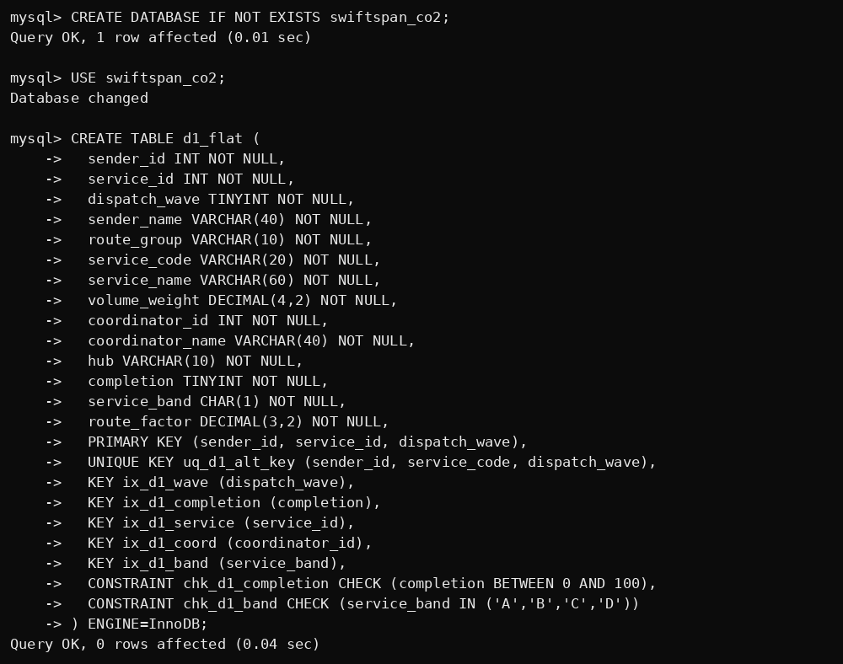
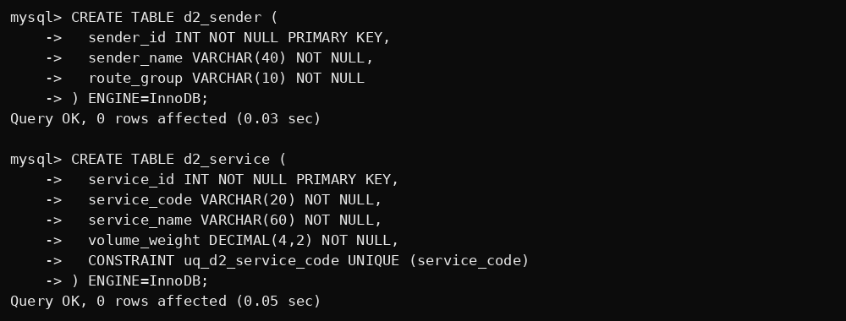
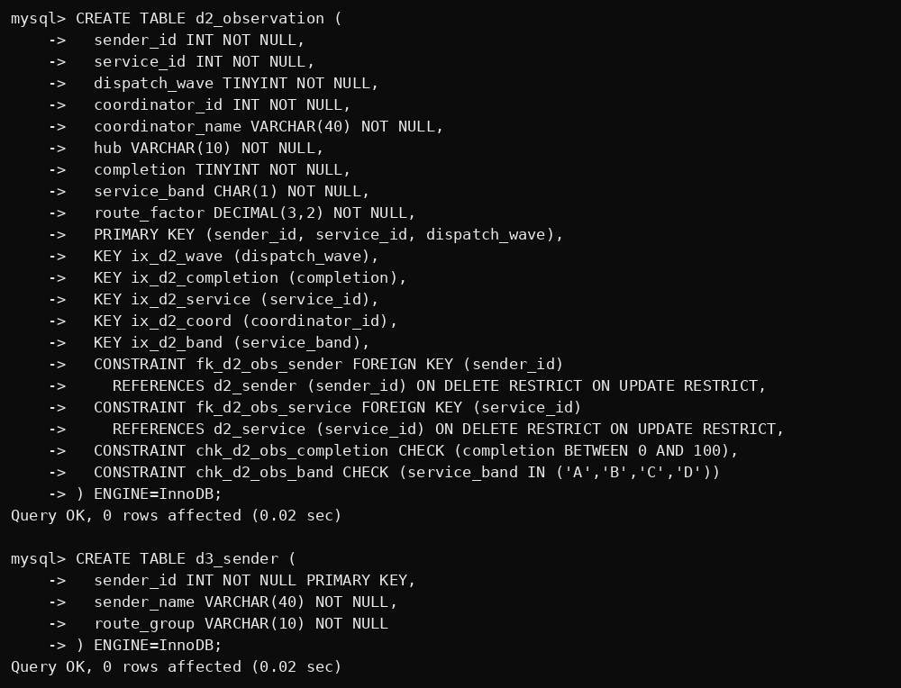
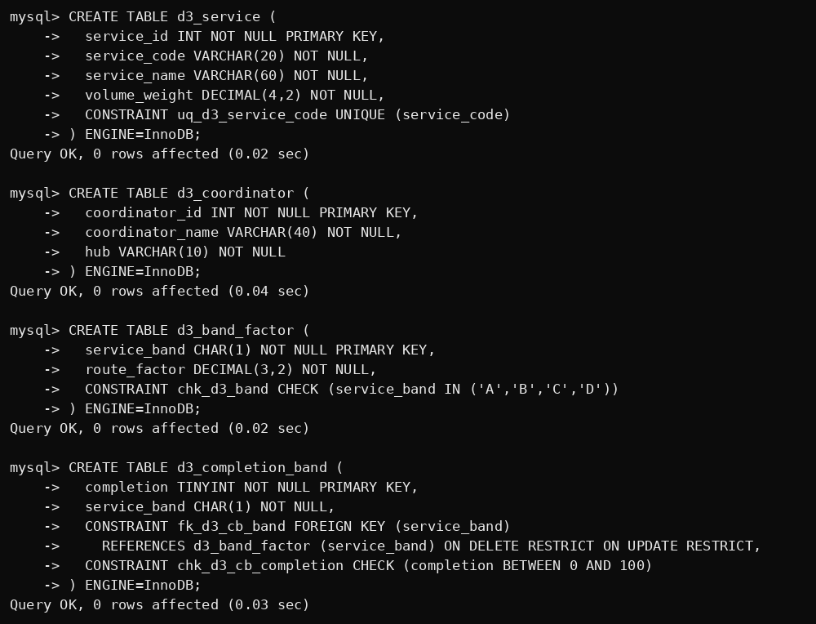
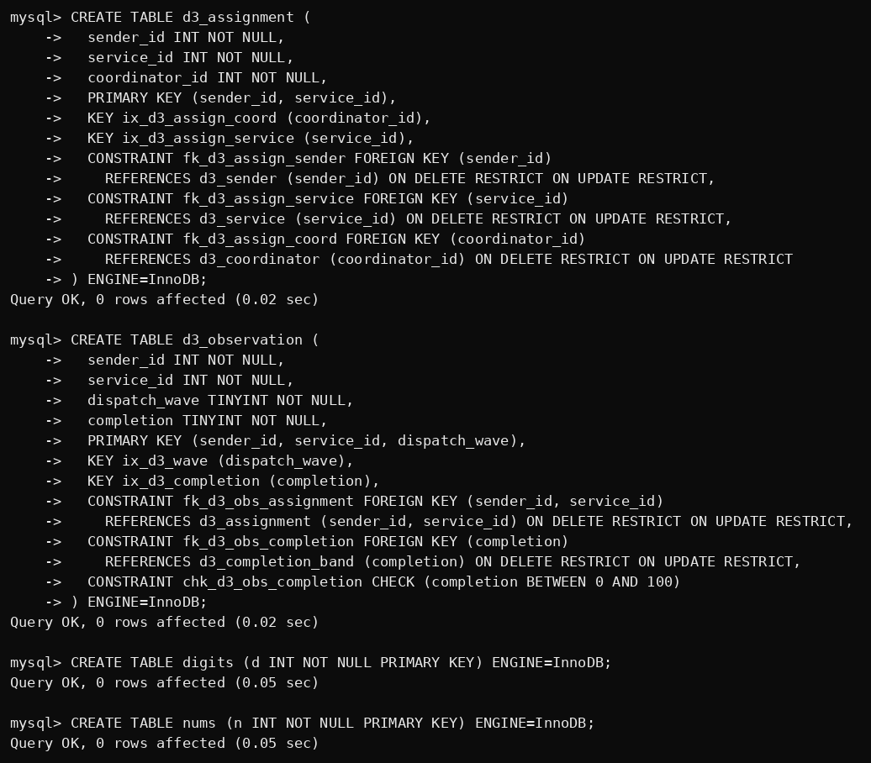
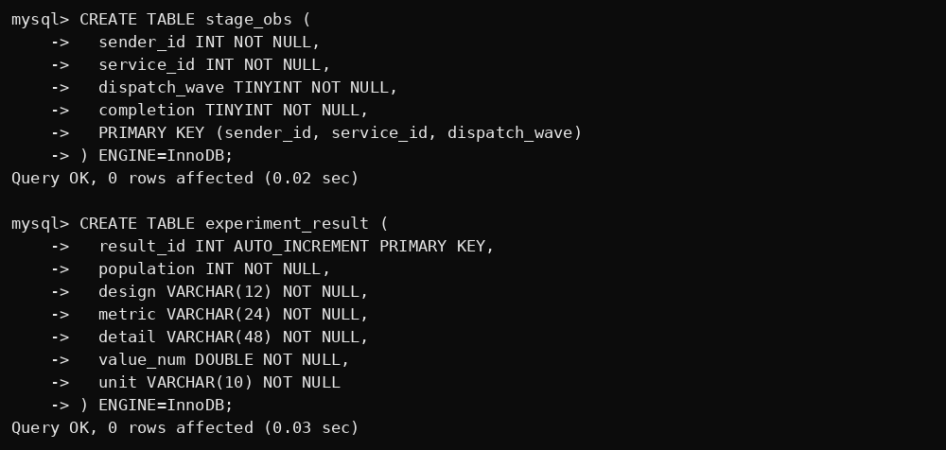


B. Load identical seeded data (procedure and CALL)
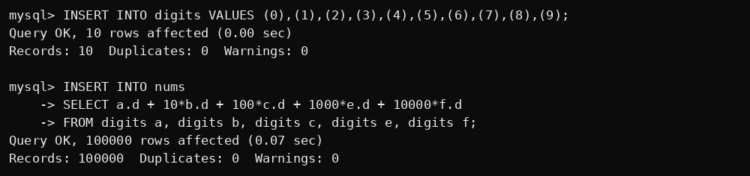
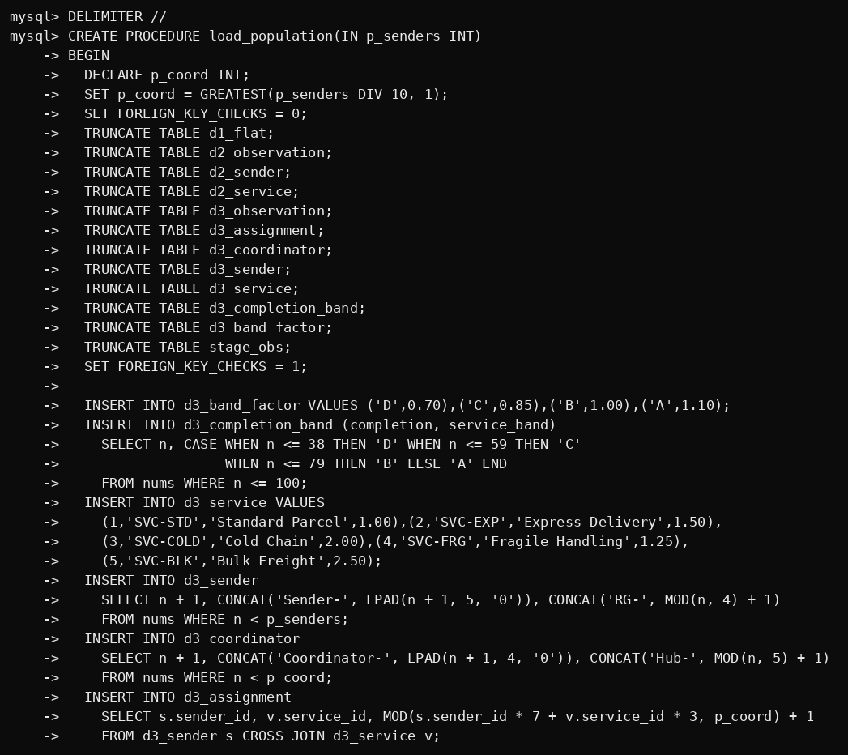
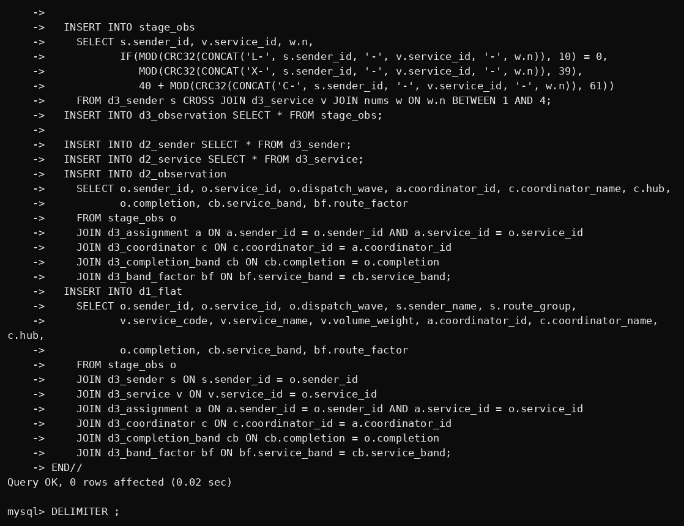

C. Row counts
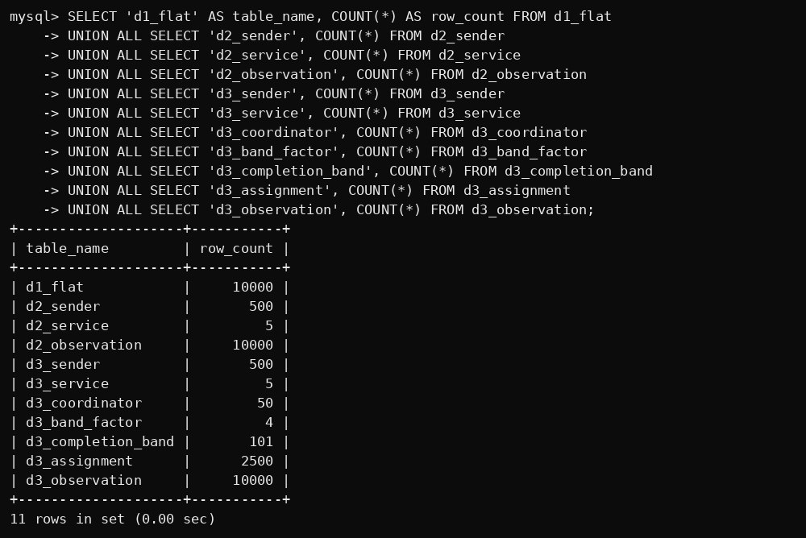

D. Use-case queries 1–2
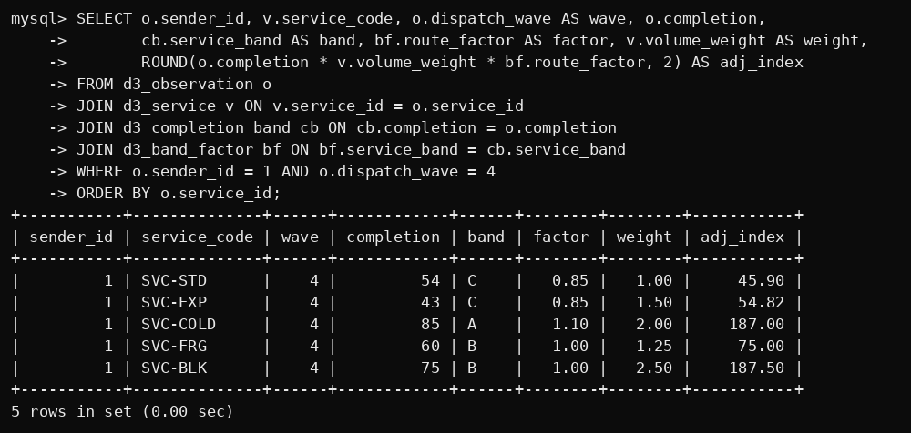
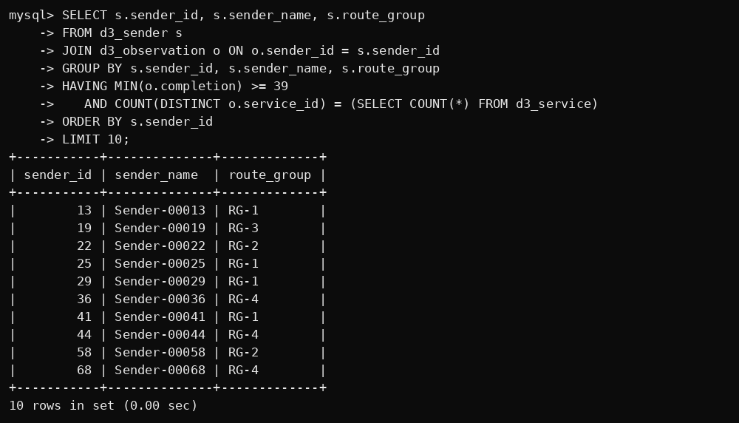

D. Use-case queries 3–5
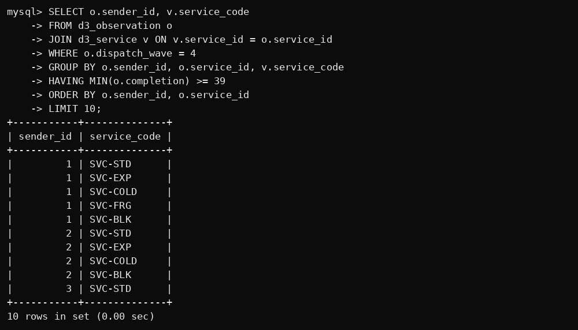
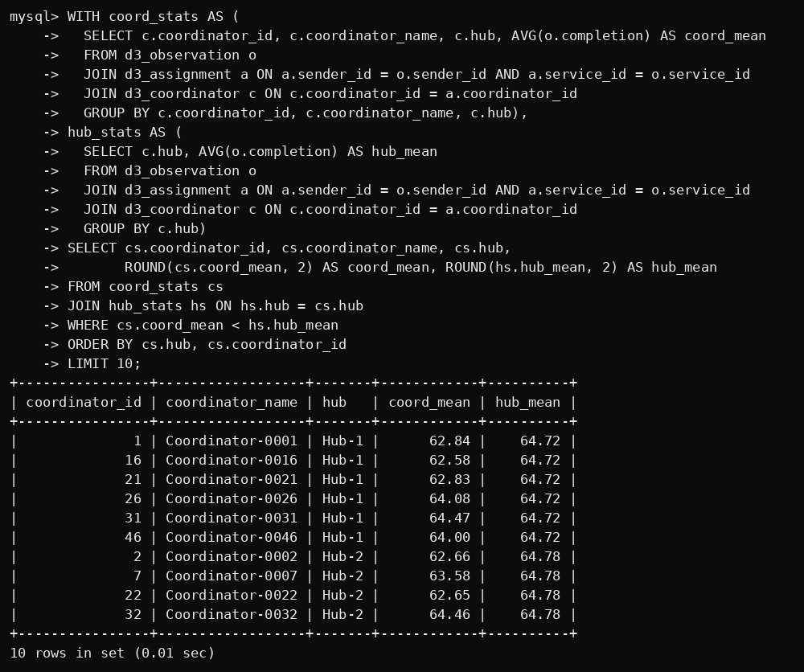
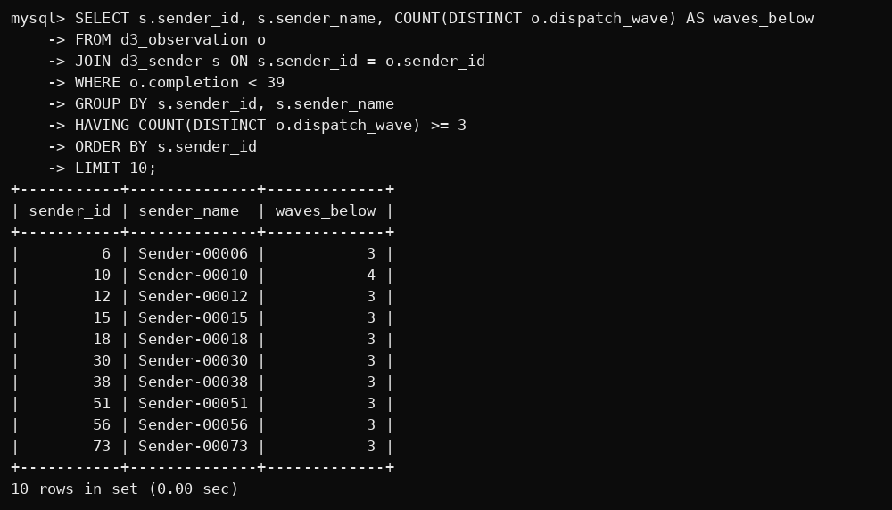

E. Views and lossless-join check
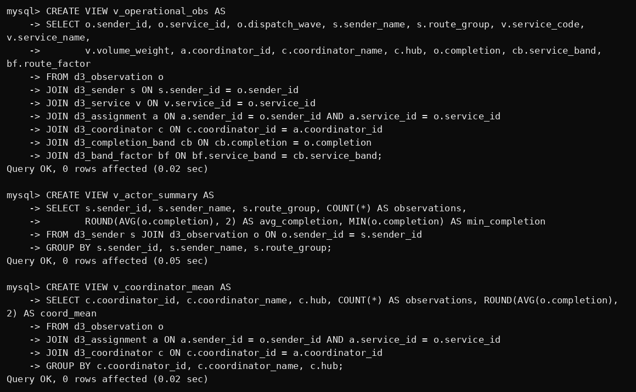
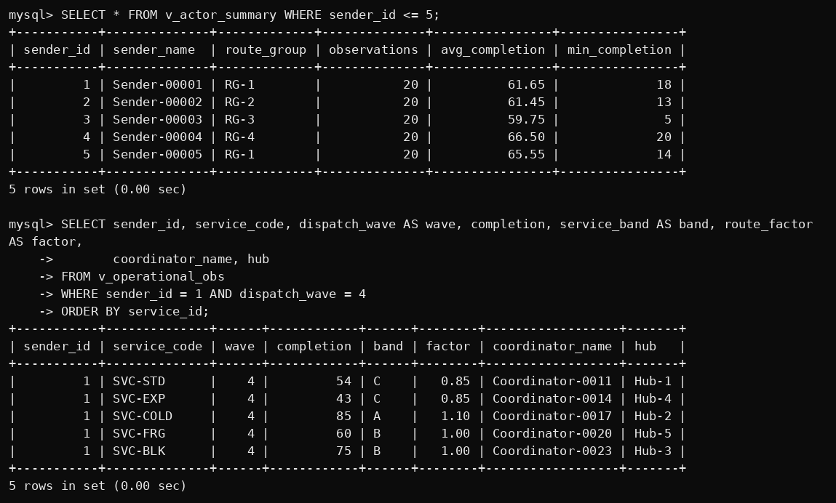
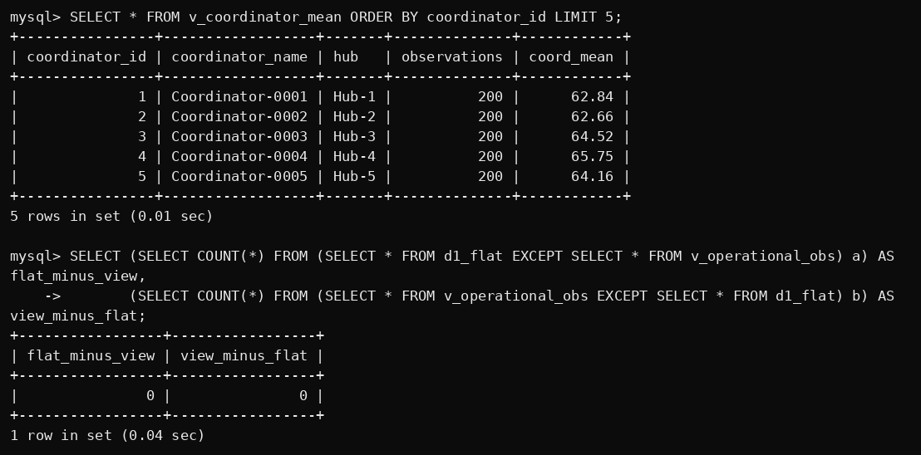

F. Update anomaly – inconsistent copies of ServiceName
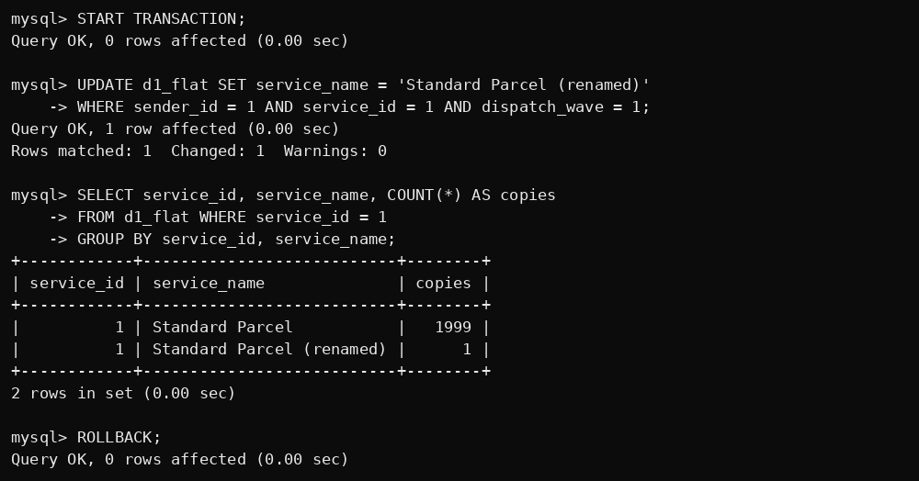

F. Insertion and deletion anomaly
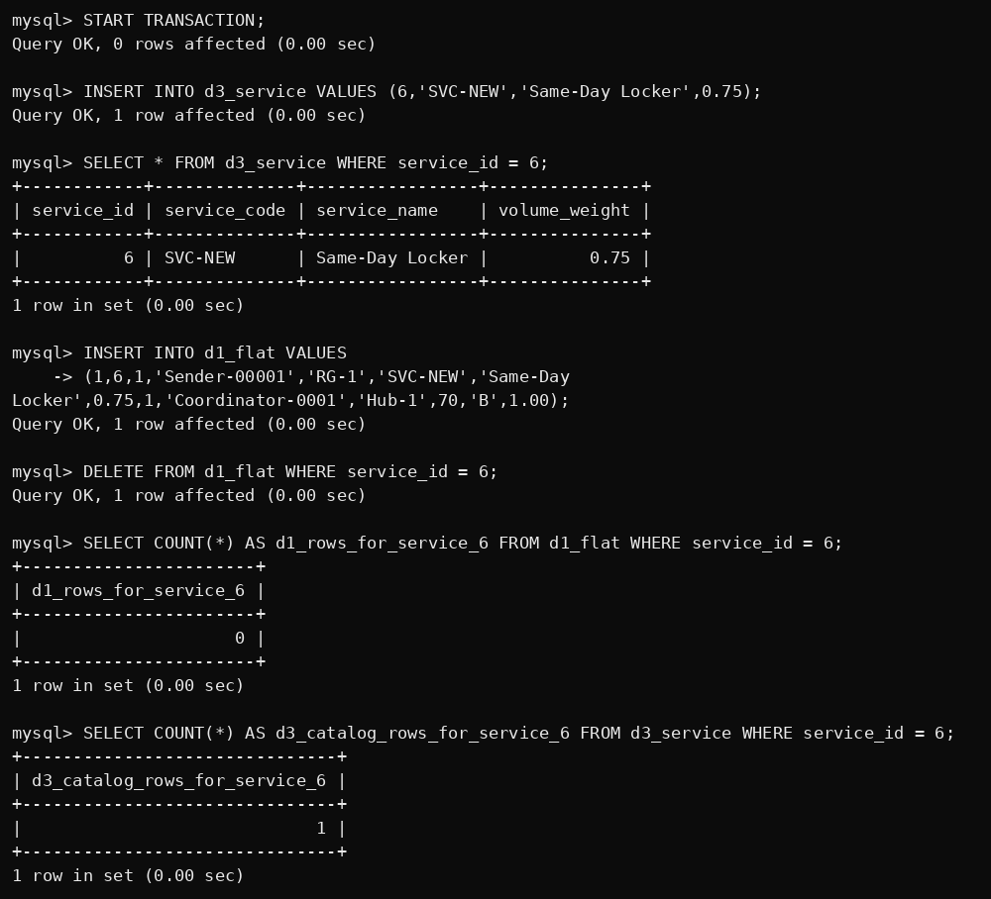

F. Rows touched – rolled-back trials at 10,000 observations
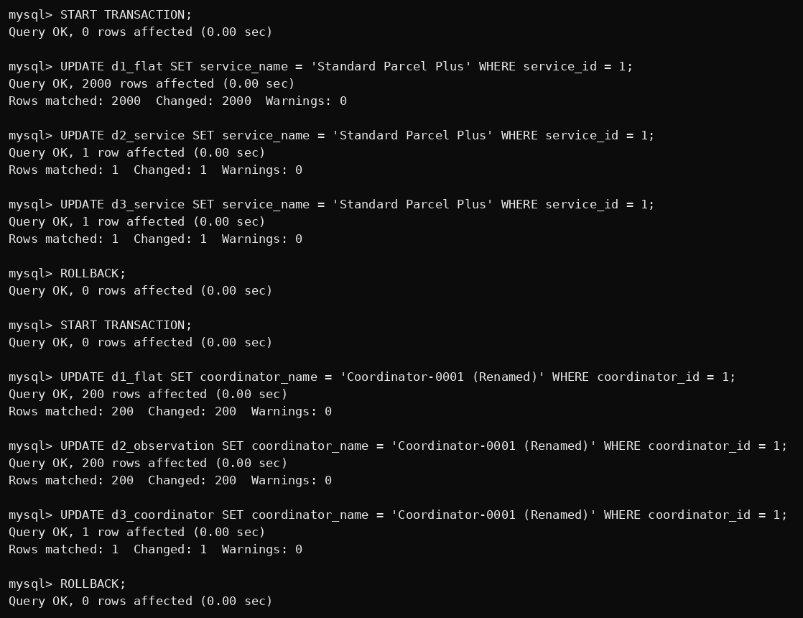
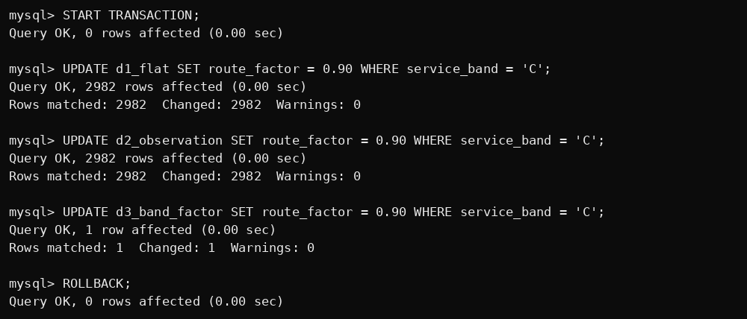

F. Rows touched – catalog change at 100,000 observations
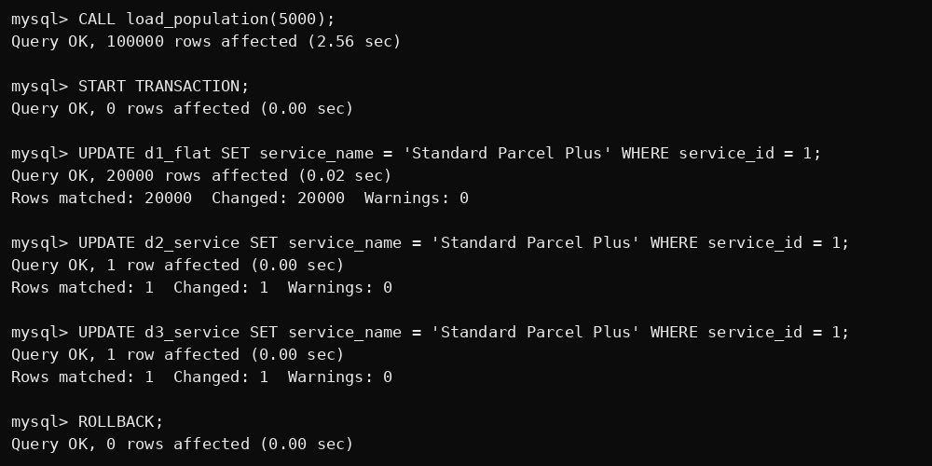

F. Rows touched – catalog change at 600,000 observations
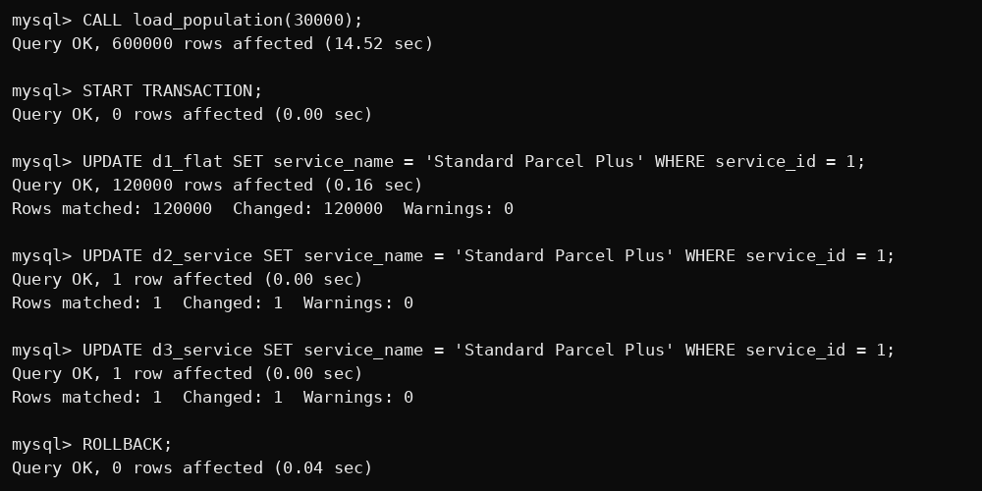

F. Repeated facts still stored in each design
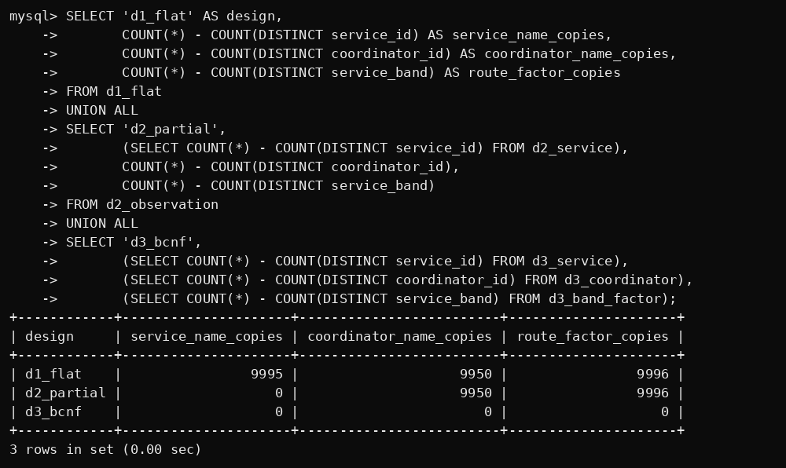

F. Policy anomaly accepted by the partial design
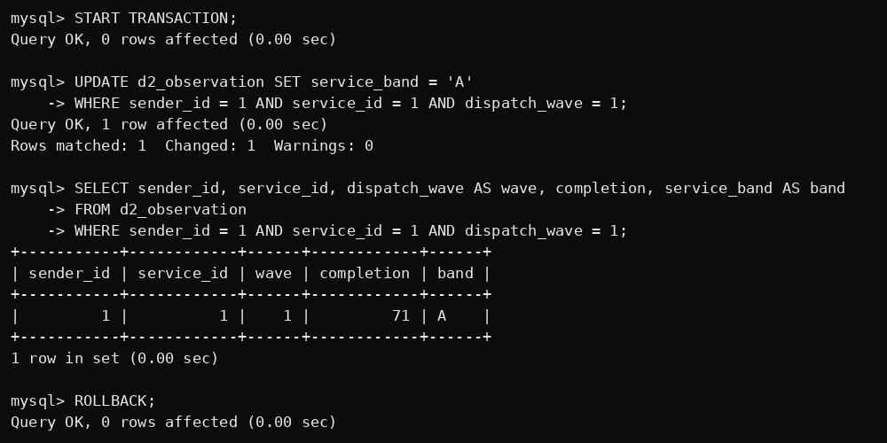

G. Experimental results – rows touched
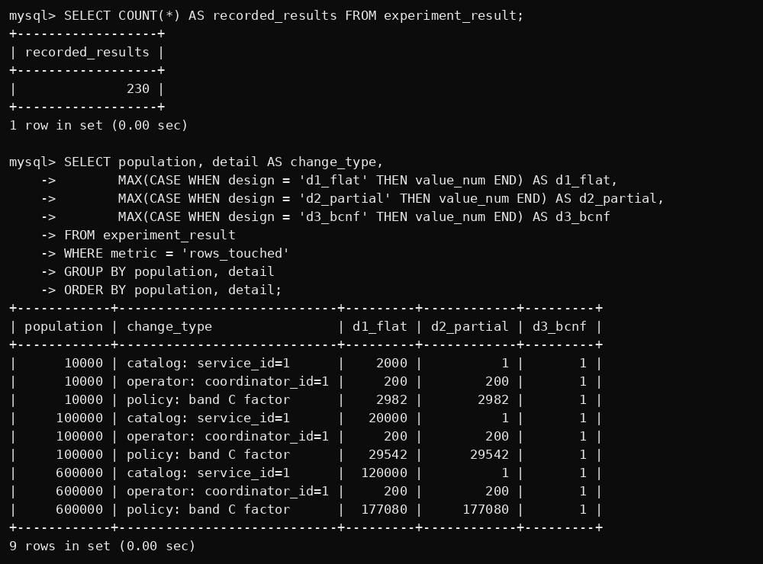

G. Experimental results – allocated bytes
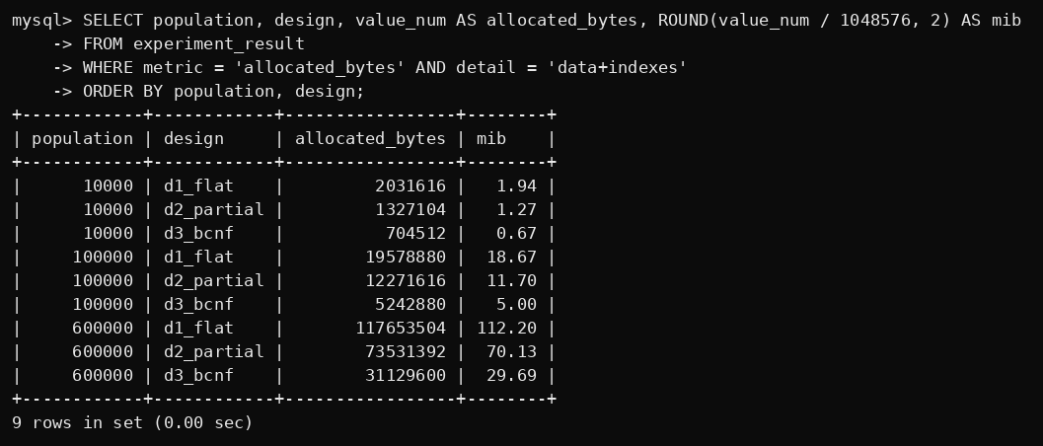

G. Experimental results – median query time
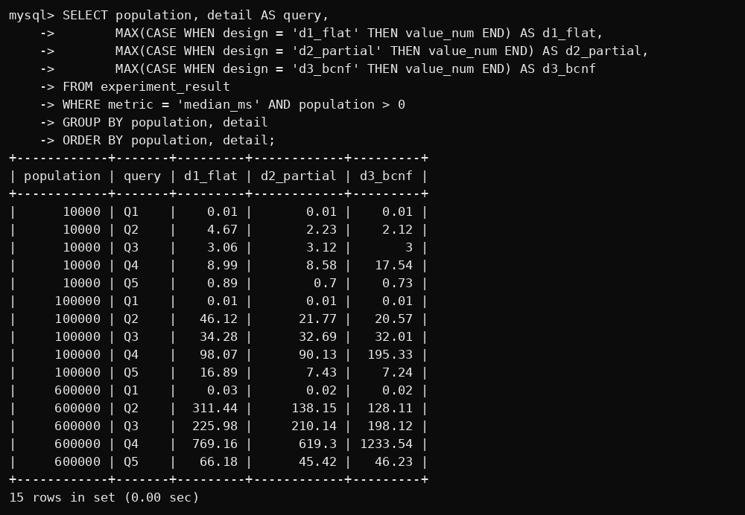

G. Experimental results – logical joins and result equivalence
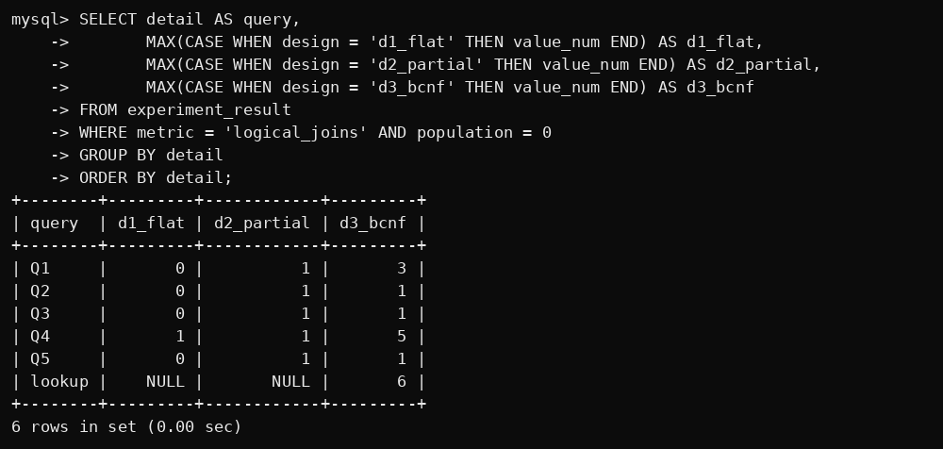
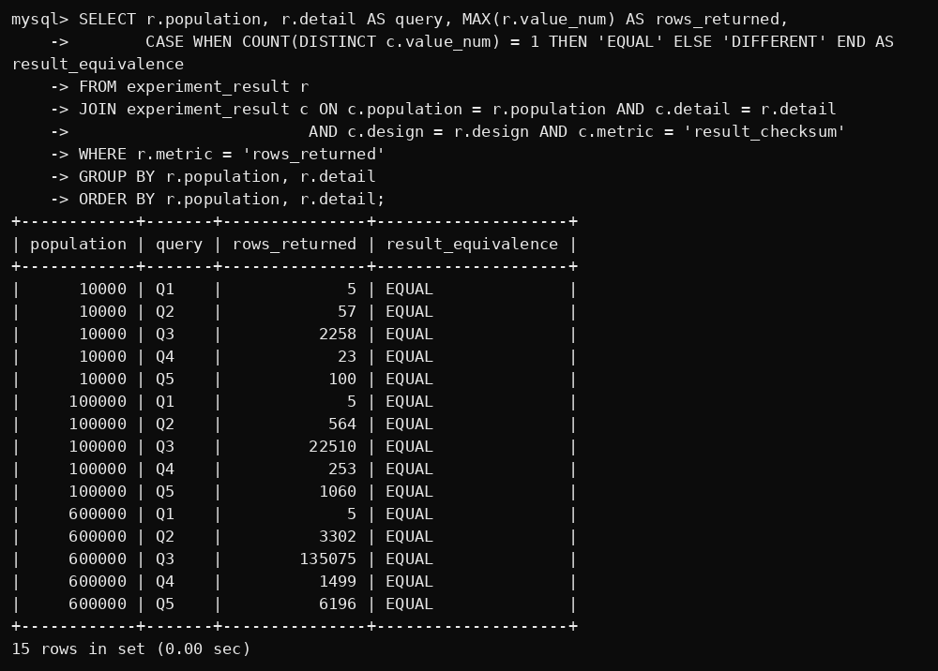

H. Read-card – build, requests per second and look-up comparison
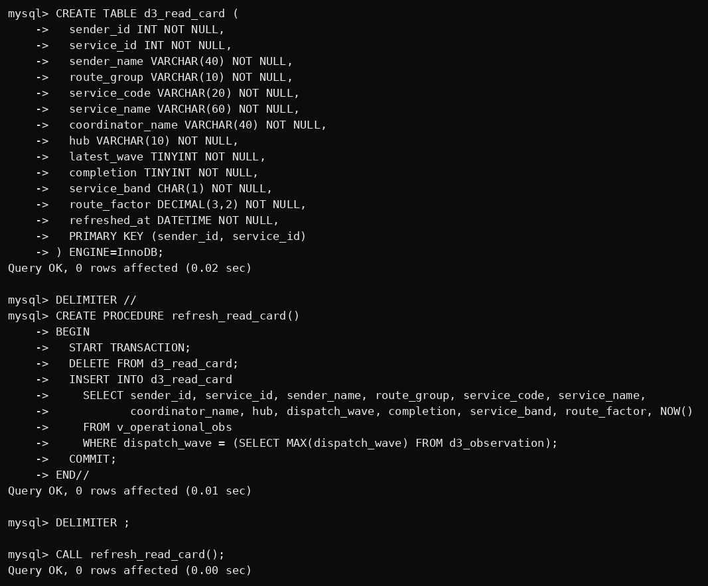
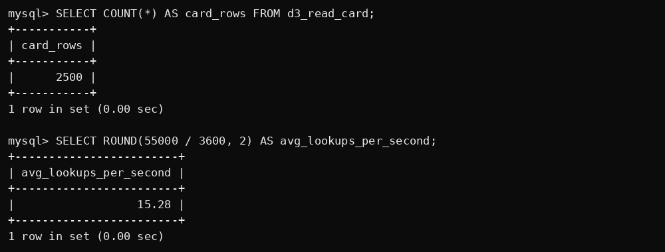

H. Read-card – normalized path vs card, validation and staleness
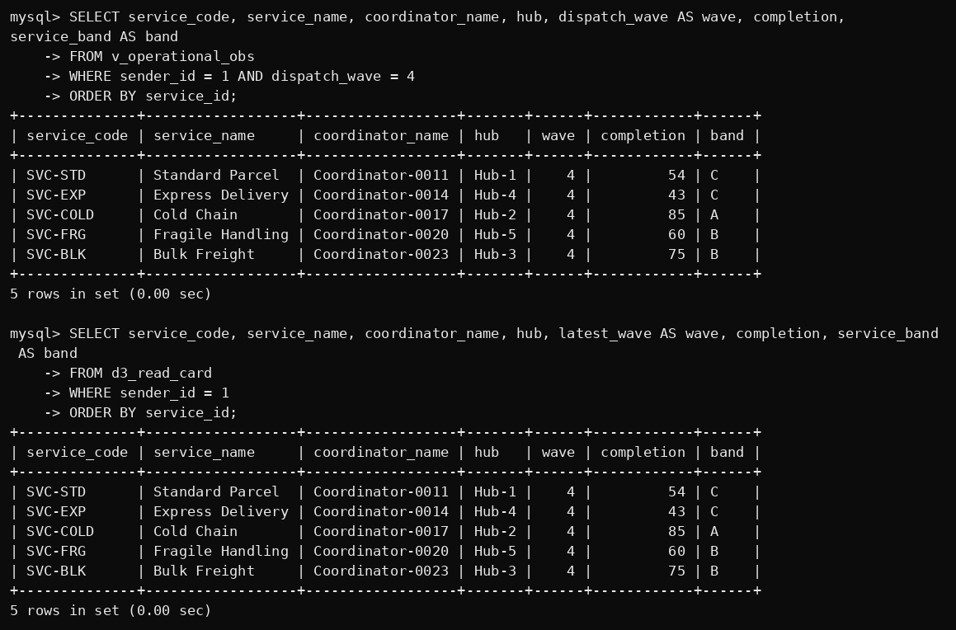
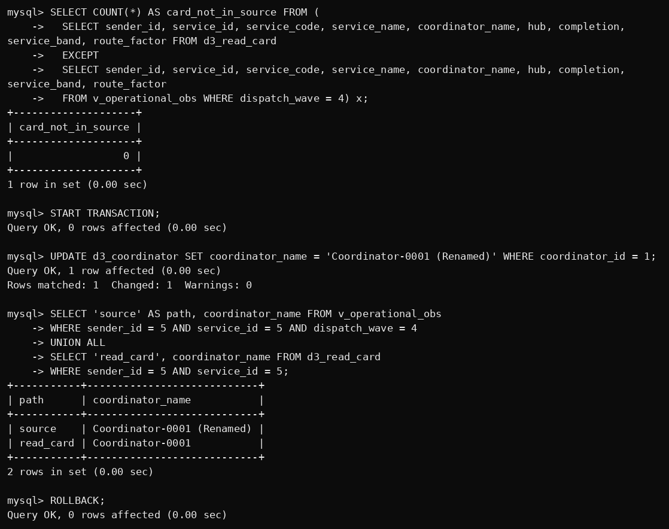

H. Read-card – measured look-up, refresh and storage
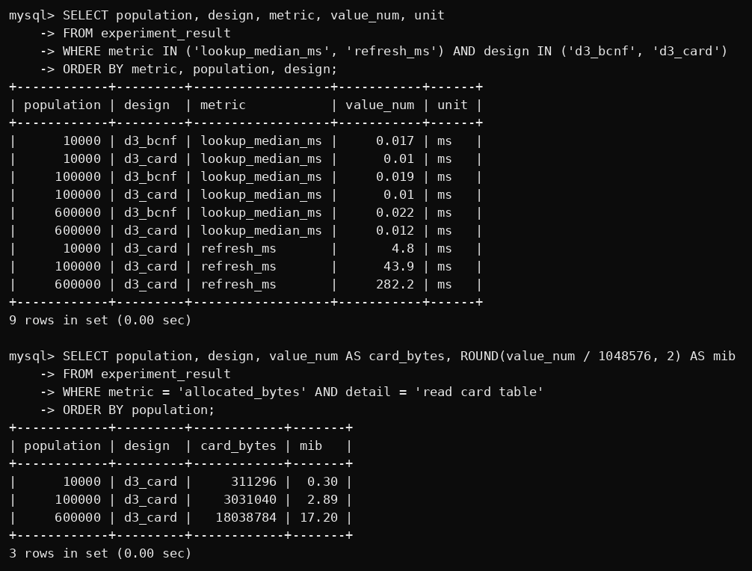

I. Invalid data tests – error messages


